Community Foundation News


No. 94 February 26, 2009

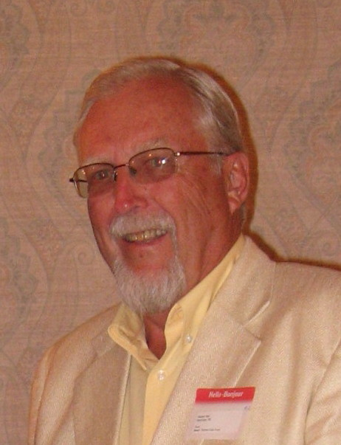

Rogers Bell was appointed to the Board in January, 2009. A native of Charlottetown, Rogers retired to PEI in 2008 after a career in the financial industry in Quebec, Alberta and Ontario. Since returning to PEI, he has joined the boards of the North Shore Community Centre and the North Shore Senior’s Housing, both located in Stanhope, where he resides with his wife Phyllis.

The Needs are Great and Many

These are tough times. Unemployment rates are rising; each day, it seems, we learn of major multiple layoffs. But layoffs are also occurring by ones and twos as well, and the hours of many workers are being reduced. Stimulus plans are being put in place but many people question if and when they will have steady work again, if ever.

The rapid and unprecedented change places unexpected and mounting pressure on social service and charitable agencies. Food bank lines are

Lengthening, unemployment lists are growing, fuel and food prices remain high, children still need nourishment and needs for health care continue. To date, donations have remained relatively strong. People seem to realize that, while they themselves are suffering others may have even greater needs. Many charitable organizations have lost their core funding or nest or rainy day fund; some have been forced to close.

And conditions may even get worse.

How should we respond?
- First of all, we should search our hearts to ensure that we are doing all we can to help others
- We should continue to honour our charitable commitments at least until the economy improves.
- If possible, increase your donations to help compensate for the rising cost of living and the increased number in need.
- Review your giving priorities and patterns to see if it reflects real need or only past practices.
- Increase our volunteer time; Invite other people to volunteer with organizations
- Give that surplus chair, bed or winter coat to a needy family

The Community Foundation News is an informal newsletter, in electronic form only, edited and published by, and at the whim of, Don Glendenning. Think of it as a letter from a friend. Forward this to others who may be interested. For further information, check our website, www.cfpei.ca or Email me at: don@glendenning.net

